***AUTONOMOUS NAVIGATION BOT***

MADE BY:

* YALMARTHY NV RONNIT GUPTA
* MANAN BALDWA

MENTOR:

HARSH MAURYA

CONTENT:-

* INTRODUCTION
* WORKING OF DIFFERENTIAL
* Lidar
* Raspberry pi
* SOFTWARES
* CONCLUSION
* ACKNOWLEDGEMENT

**INTRODUCTION**

Autonomous navigation is used to maneuver around terrains without the surveillance of a person. The bot utilizes a LIDAR for 2D mapping and thus navigates through obstacles. It utilizes differential for changing

direction of motion which helps to reduce operational Arduino and raspberry pi are programmed to permit the working of differential according to the inputs from LIDAR with precision.

The chassis is designed to withstand the weight of components and impacts produced while navigating in rough terrains.

**DIFFERENTIAL**

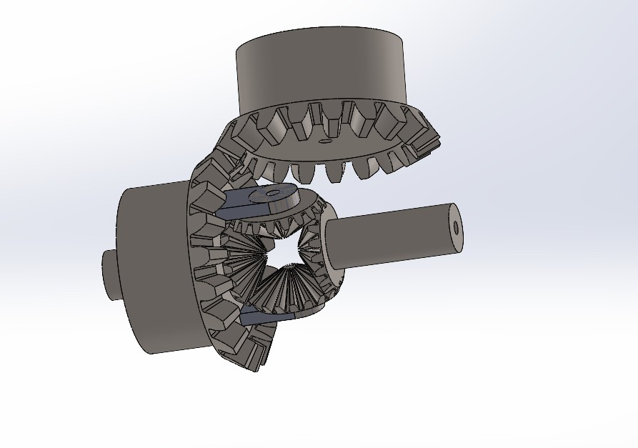It is a type of motor which allows the wheels to rotate at different speeds which helps in changing direction of the bot.

**For turning left:** the right wheel rotates at much higher speed than left.

**For turning right:** the left wheel rotates at much higher speed than right.

**LiDAR**

LiDAR(Light Detection and Ranging) technology allows self-driving vehicles to make calculated decisions with its ability to detect objects in its immediate environment. It can be thought of as a vehicle's “set of eyes” and the most important component in making self-driving vehicles a reality.

**Raspberry pi**

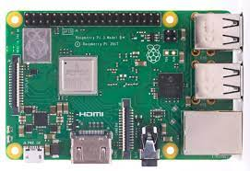It takes input from lidar and process them and give suitable output to the chassis to move in terrain accordingly by controlling the motion of differential.Basically, it is a small low cost computer fitted in autonomous bot.

**SOFTWARES**

Solidworks was used for designing of the chassis and its components.

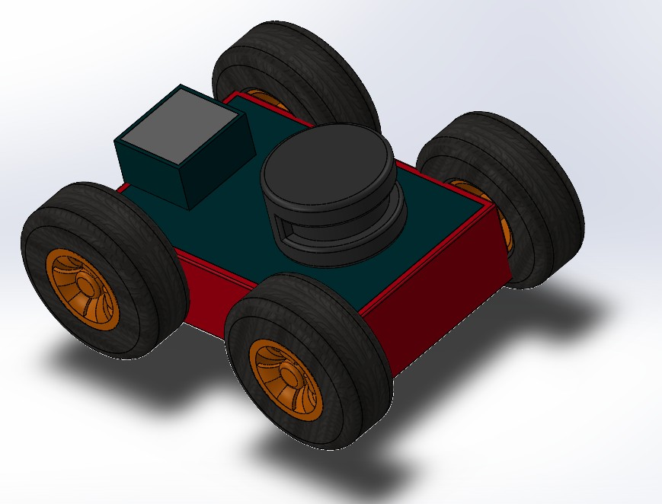

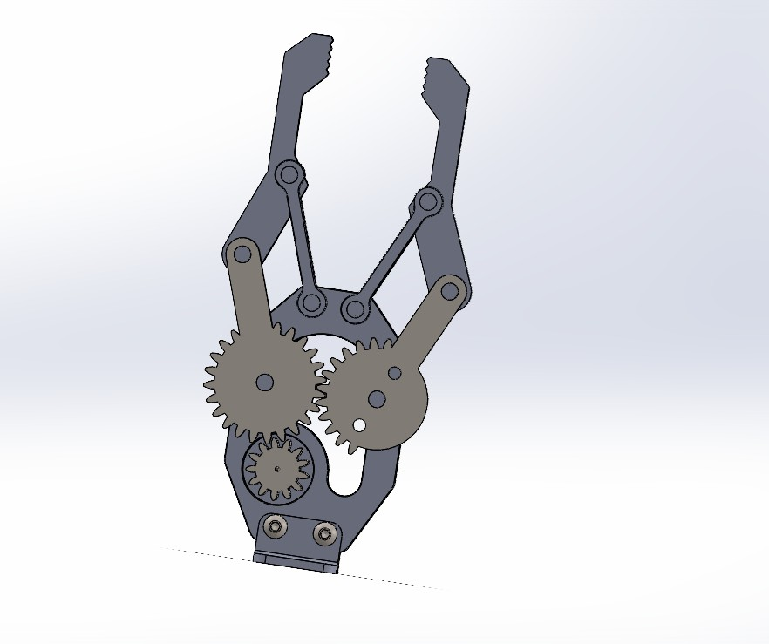**PRACTICE DESIGNS IN SOLIDWORKS**

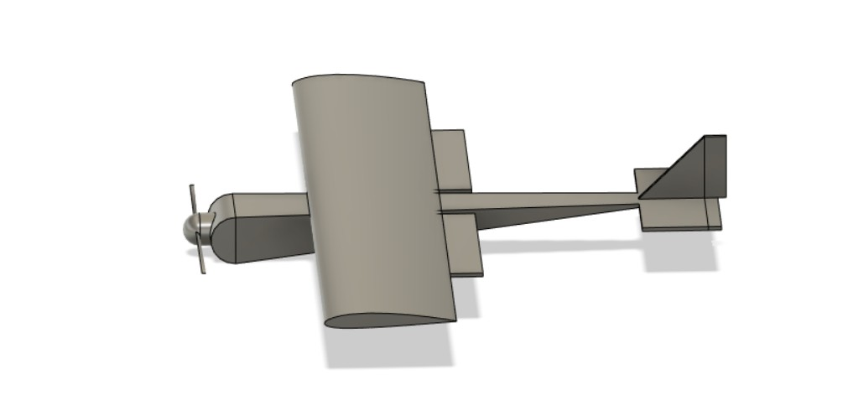

**CONCLUSION:**

The bot can navigate properly in flat terrains and using LIDAR it can map the surroundings. Within the box sensitive electrical components are placed to avoid any damages. LIDAR is placed on the box and connected to raspberry pi through holes.

**ACKNOWLEDGEMENT:**

The project was conducted by ARIES. The project was conducted under the supervision of Harsh Maurya, to whom we want to express gratitude for guiding and supporting us throughout the project. We

acknowledge the support received from Harsh Maurya during this project.